|  |  |
| --- | --- |
| RAS  Basic Quick Start Guide | Abstract  This document provides users with a quick way to get started using RAS. |

# Table of Contents

Table of Contents 2

Introduction 3

Getting Started 4

# Introduction

This document is meant as a quick start guide for RAS users who plan on using the dashboard functionality. You’ll be shown how to log in, as well as how to access the dashboards.

# Getting Started

Use your browser to navigate to <https://ras.leclanche.com> and log in using the credentials that have been provided to you.

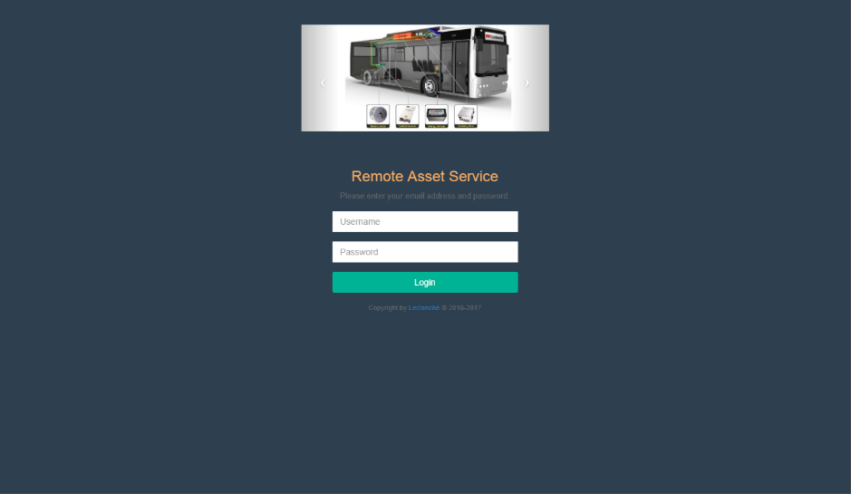

Once logged in, you’ll be greeted with the following screen:

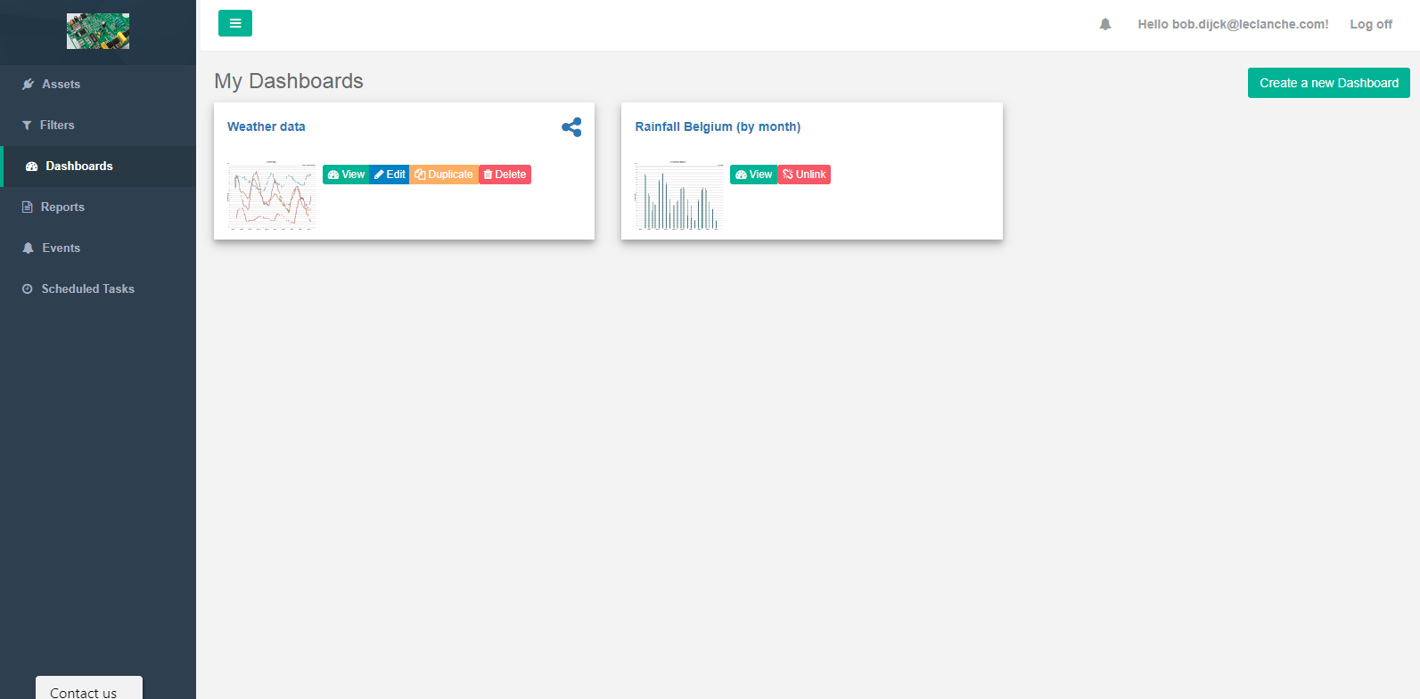

The page can be divided into three sections with distinct functions:

* On the left, you’ll find the menu bar, which is used to navigate the different RAS modules. Depending on your account, the list of modules that is shown will be different from the list in the screenshot above.
* The top section allows users to log out and view their notifications through the bell icon.
* The bottom section displays the contents of the currently selected module.

In the ‘Assets’ module, available in the menu bar, you’ll see which assets are available to your company. You can click each of these assets to view some details about the assets.

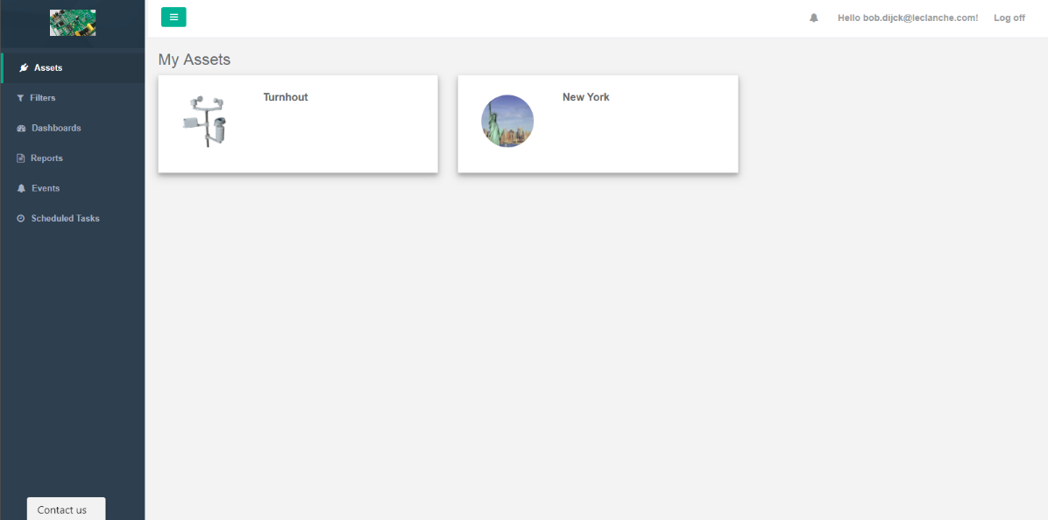

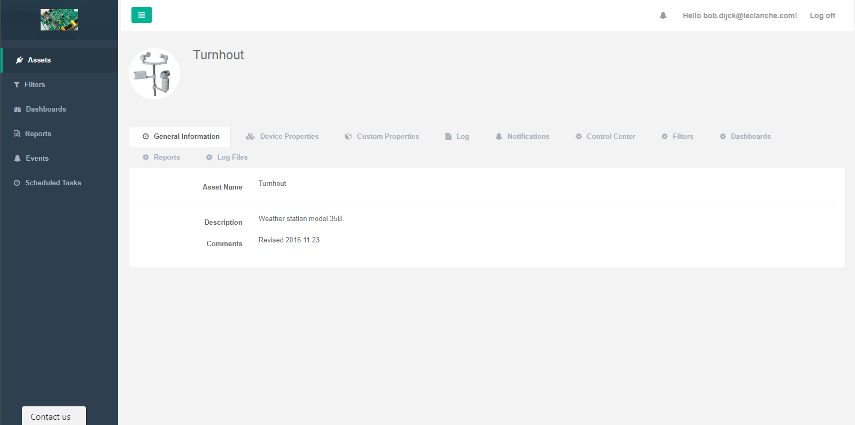

In the ‘Dashboards’ module, all dashboards are listed that are available to you. This includes dashboards that you have created (if allowed by your account settings) and dashboards that have been shared with you. This page is also the default landing page after logging onto RAS.



You can view a dashboard by clicking the dashboard title (‘Weather data’ or ‘Rainfall Belgium (by month)’ in the example above) or the green ‘View’ button.

With a dashboard, you’ll be able to visualize asset data in the way the dashboard creator intended. A dashboard can contain multiple graphs, images, maps and many more things.

